**Animation No. :-**

**Aim :- Create a motion tween in Flash.**

1. Open a new Flash Document.
2. Draw a simple circle.
3. Insert a new keyframe after some frames.
4. In the keyframe circle is moved to the other end of the frame.
5. Similarly insert a third keyframe and in it the circle is moved downward.
6. All the frames in the timeline are set to Motion Tween.

**Created By :- Rohit Aggarwal**

**Roll No :- 7CS-097**

**OUTPUT :**

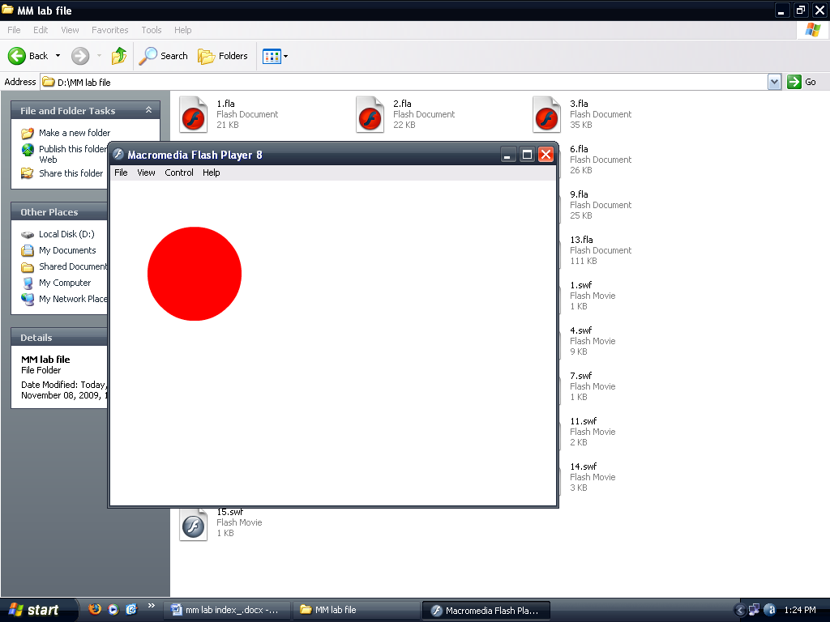

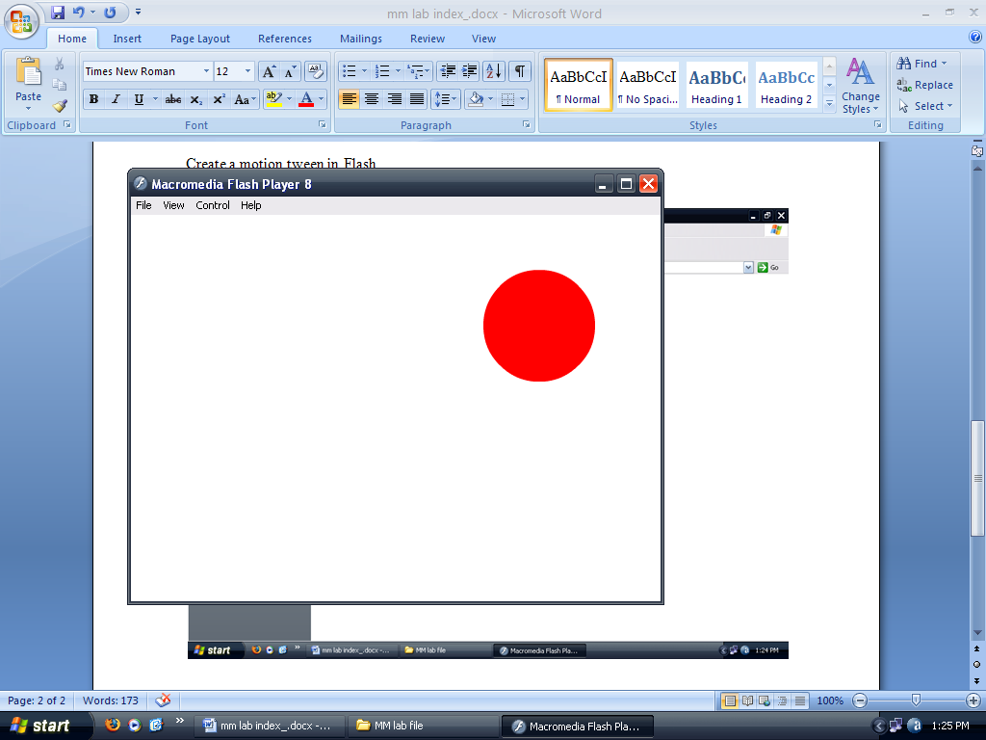

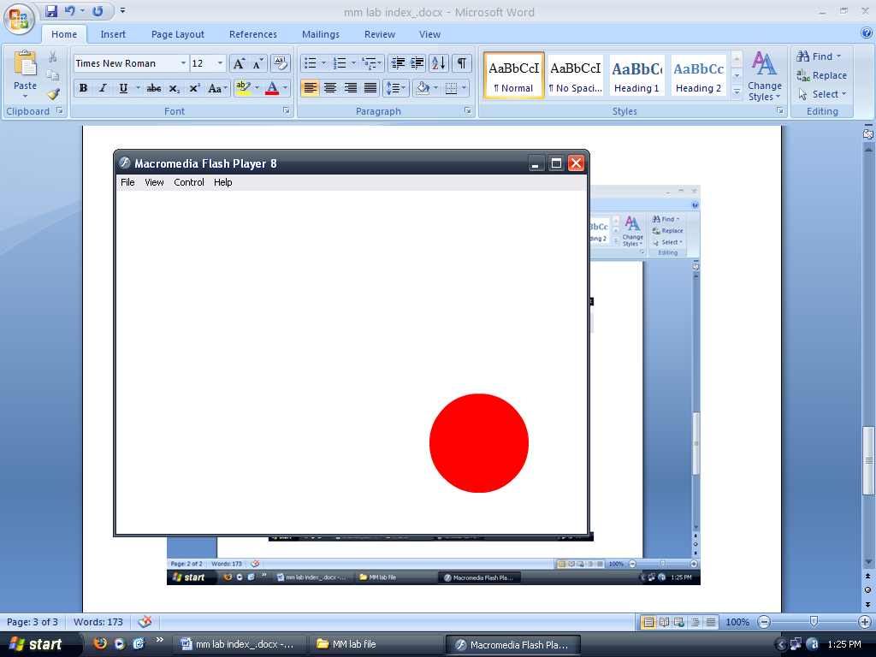

**Animation No. :-**

**Aim :- Create a guided motion tween in Flash.**

1. Open a new Flash Document.
2. A simple circle is drawn.
3. A motion guide layer is added in the timeline.
4. The required path which is a downward parabola here is drawn in the motion guide layer.
5. The object which is to be motion guided is set at beginning of the path at the 1st frame.
6. The object is set at the end of the path at the last keyframe.
7. The frames in the timeline are set to motion tween.

**Created By :- Rohit Aggarwal**

**Roll No :- 7CS-097**

**OUTPUT :**

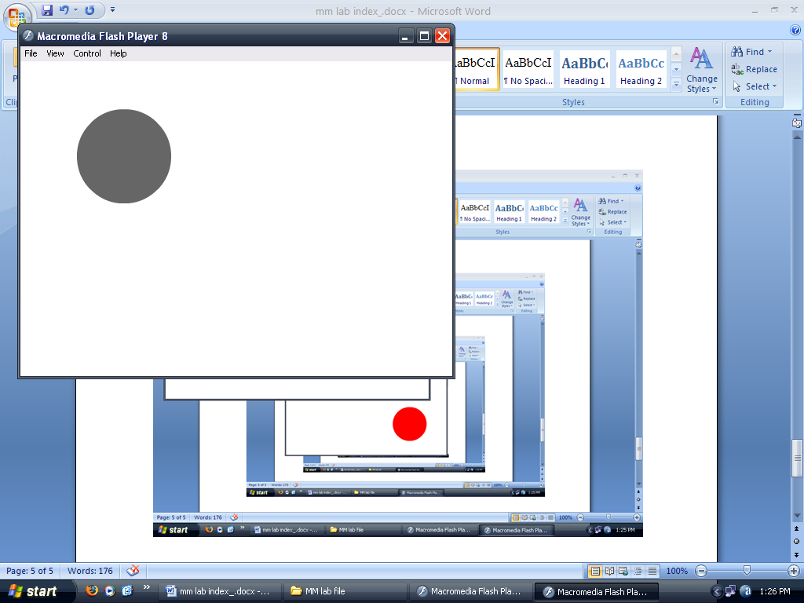

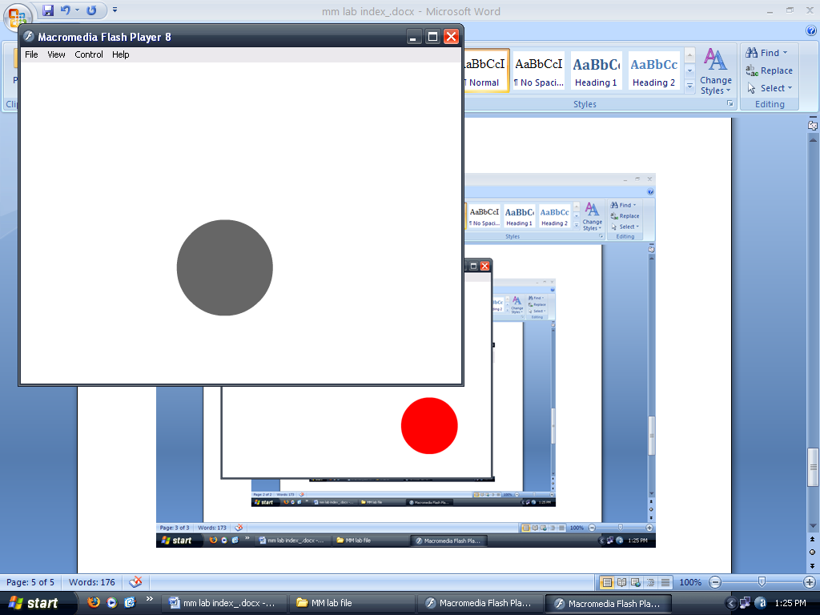

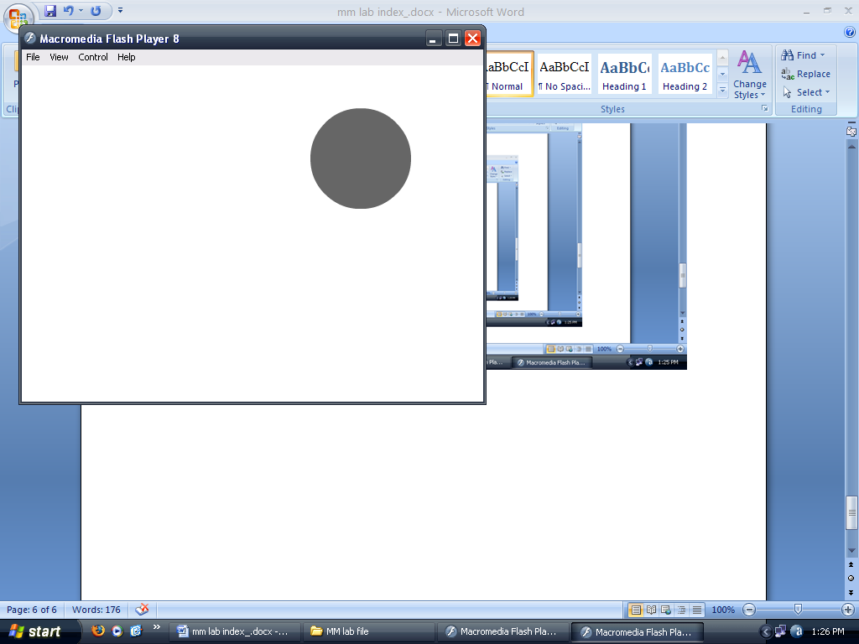

**Animation No. :-**

**Aim :- Create a zooming effect using basic tweening.**

1. Open a new Flash Document.
2. Any Text is written (here Animation using Flash 5.0).
3. Text is transformed to make a group.
4. At 1st keyframe the text is set.
5. At the last keyframe the text object is increased in size.
6. The frames in the timeline are set to Motion Tween.

**Created By :- Rohit Aggarwal**

**Roll No :- 7CS-097**

**OUTPUT :**

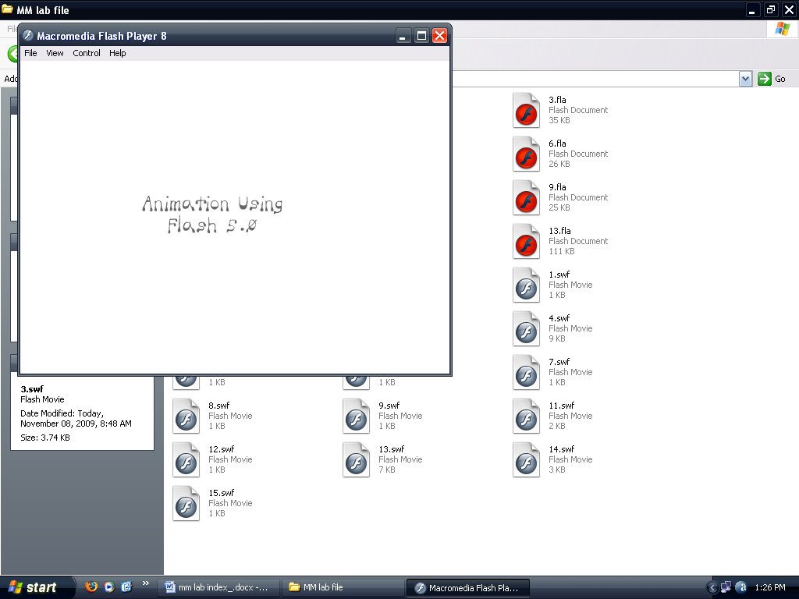

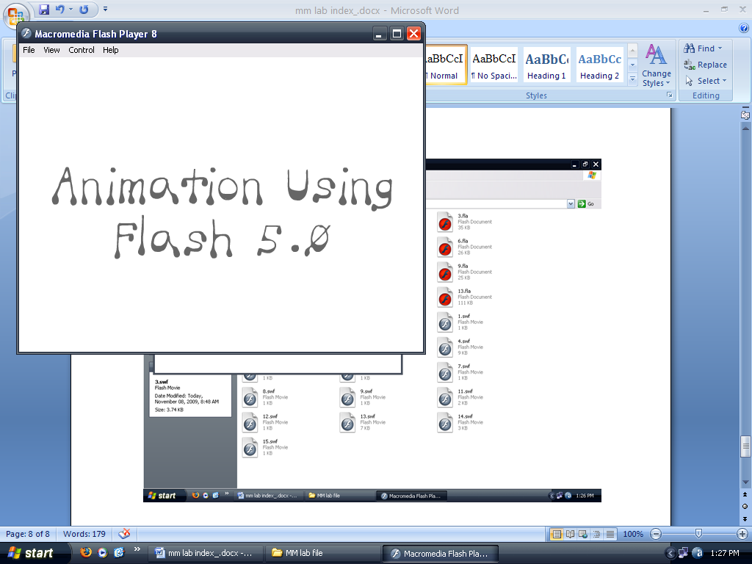

**Animation No. :-**

**Aim :- Create a shape tween in Flash.**

1. Open a new Flash Document.
2. A Circle is drawn in the 1st keyframe
3. Insert a key frame after some frames.
4. Polygon is drawn in the next keyframe.
5. Text in written and ungrouped in another, third keyframe.
6. All frames are selected and set to shape tween.

**Created By :- Rohit Aggarwal**

**Roll No :- 7CS-097**

**OUTPUT :**

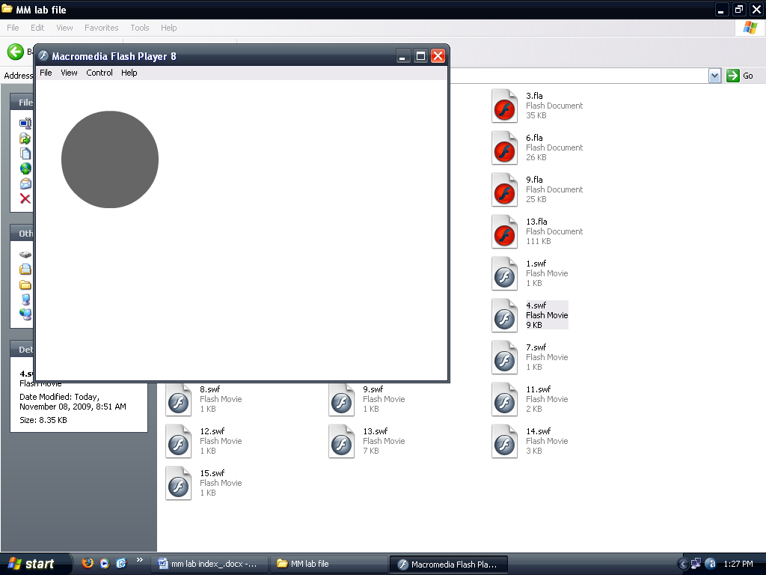

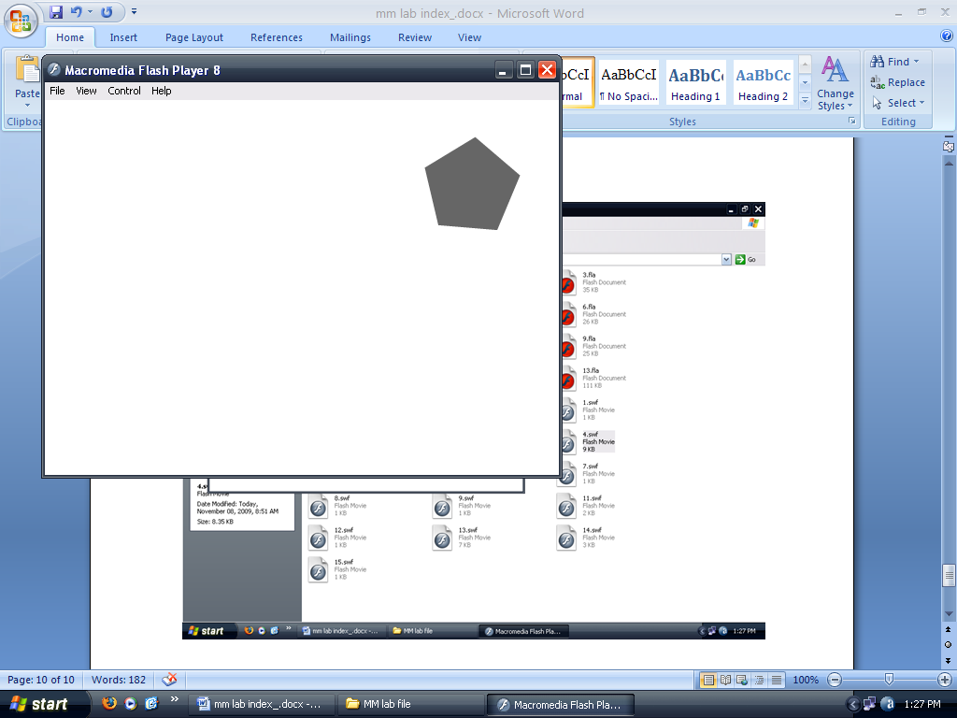

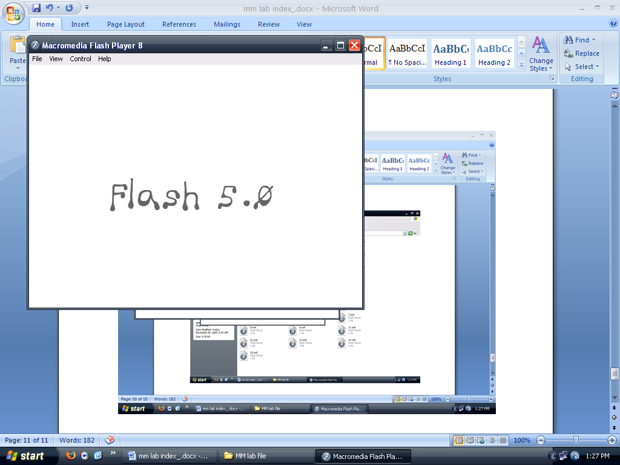

**Animation No. :-**

**Aim :- Create logo of your college using Flash.**

1. Open a new Flash Document.
2. Logo is simply drawn with the help of :
   1. Line tool
   2. Pencil tool
   3. Rectangle tool
   4. Free transform tool.

**Created By :- Rohit Aggarwal**

**Roll No :- 7CS-097**

**OUTPUT :**

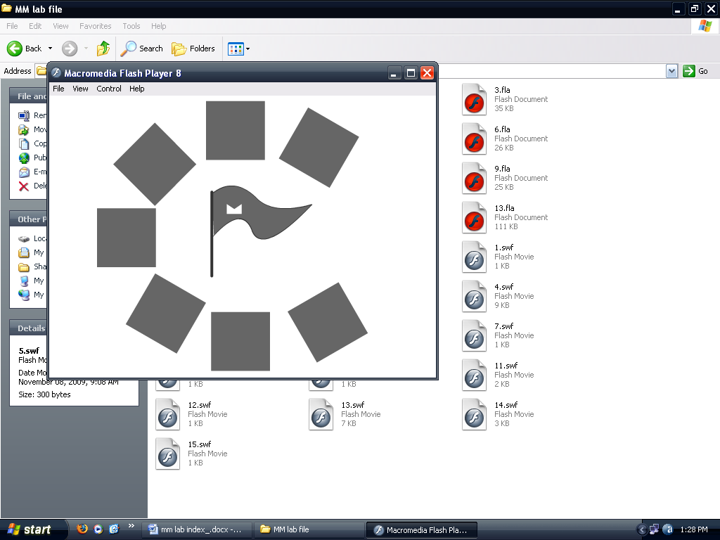

**Animation No. :-**

**Aim :- Design a bouncing ball in Flash.**

1. Open a new Flash Document.
2. A ball is drawn.
3. It is brought downward in the next keyframe (say 25).
4. Brought slightly up in the next keyframe (say 50).
5. All frame are set to motion tween.

**Created By :- Rohit Aggarwal**

**Roll No :- 7CS-097**

**OUTPUT :**

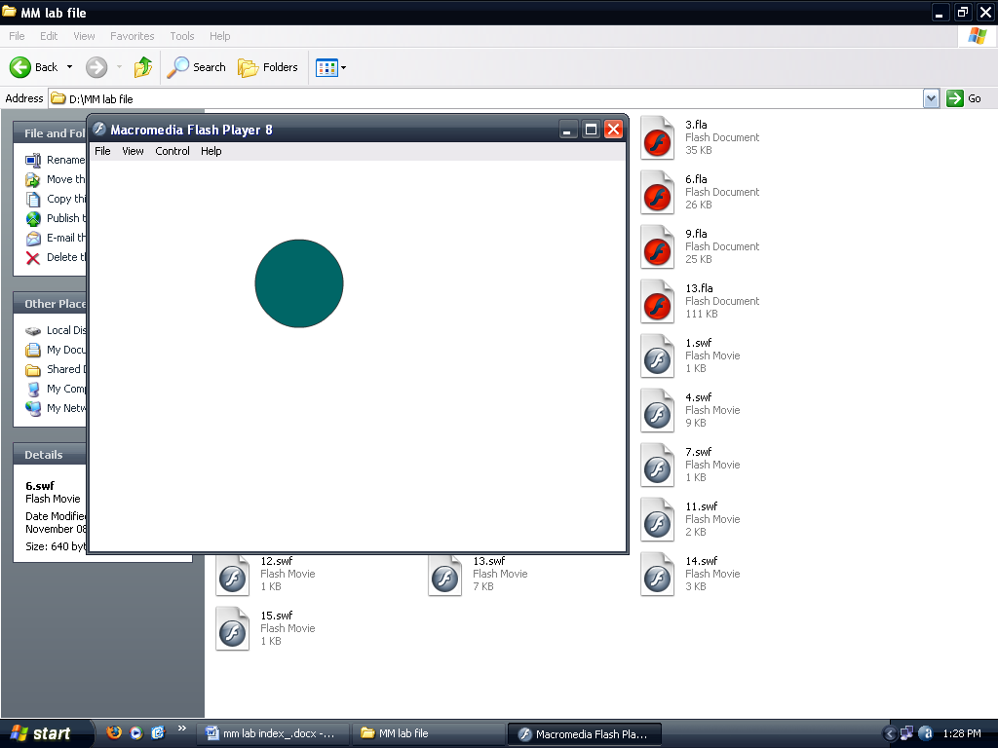

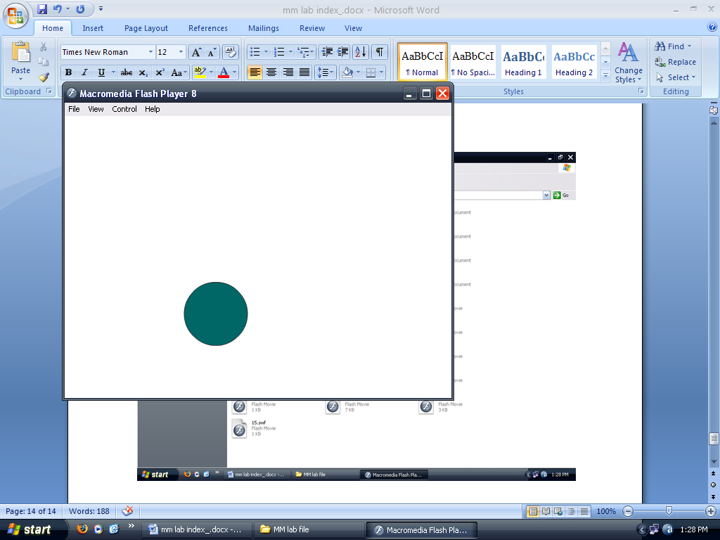

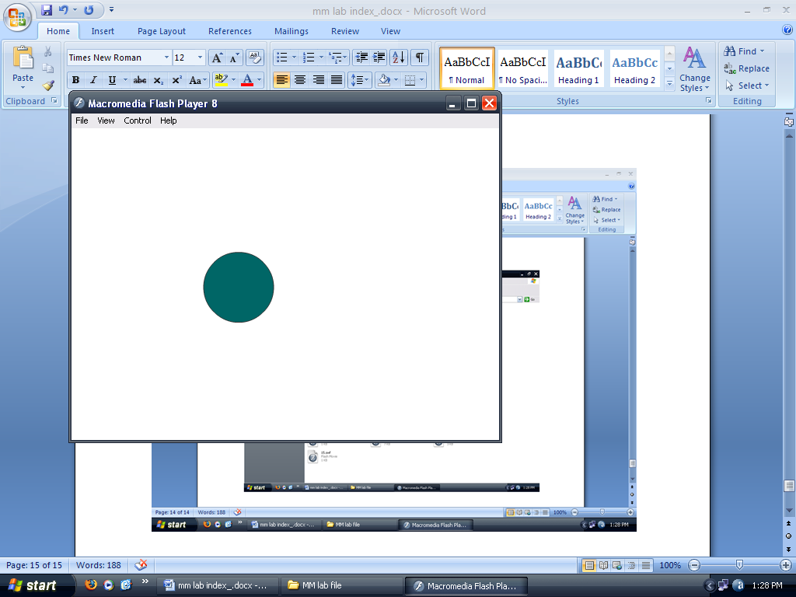

**Animation No. :-**

**Aim :- Create animated bow and arrow in Flash.**

1. Open a new Flash Document.
2. A bow and an arrow are made with the help of:
   1. Line tool
   2. Pencil tool
   3. Circle tool
3. The string , the bow and the arrow are all made in different layers so as to simplify the task.
4. String and arrow are both made to come a little backwards using shape tween and motion tween respectively.
5. The arrow is moved towards the other end in the next key frame and the frames in the layer with the arrow are set to motion tween.
6. The bow is made to oscillate in its fixed position with the help of shape tweening.

**Created By :- Rohit Aggarwal**

**Roll No :- 7CS-097**

**OUTPUT :**

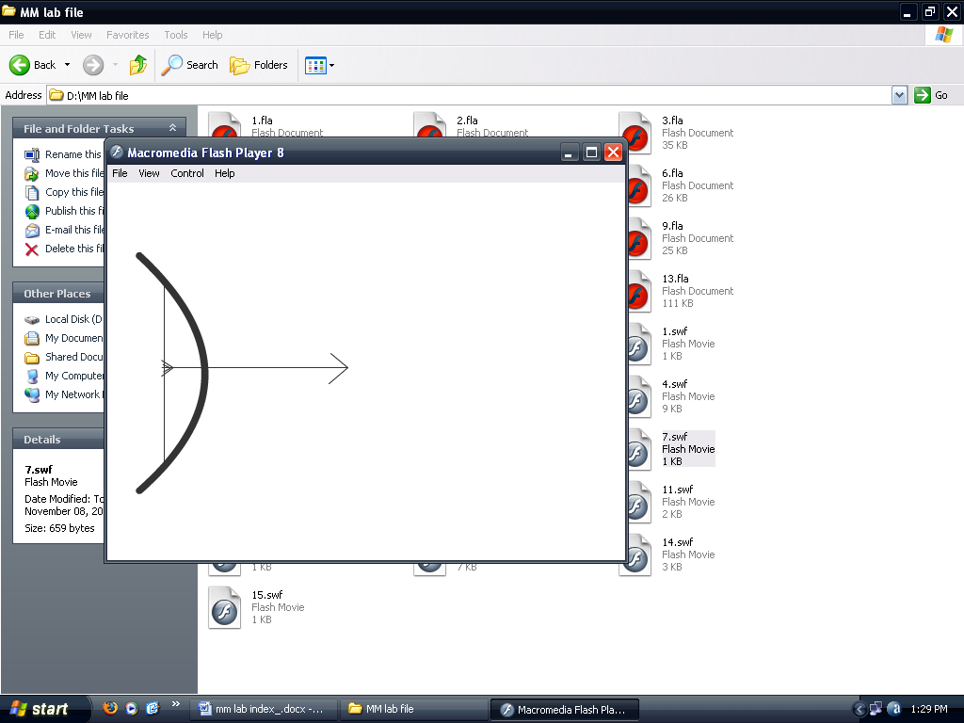

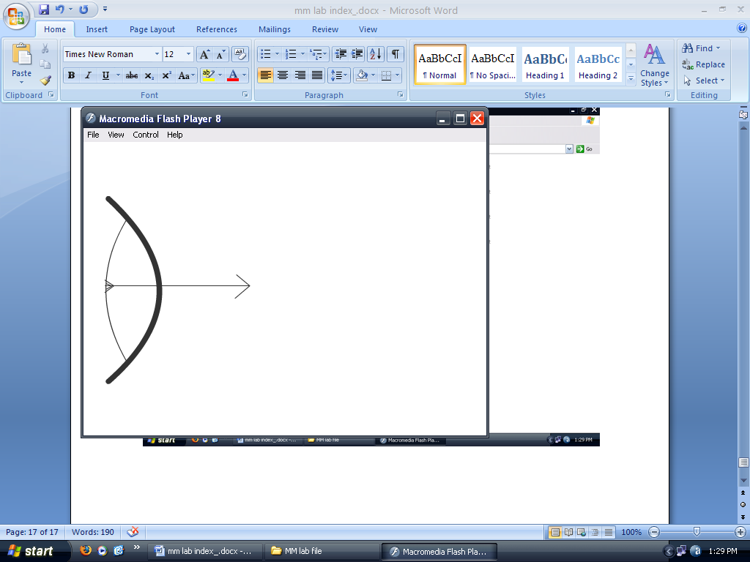

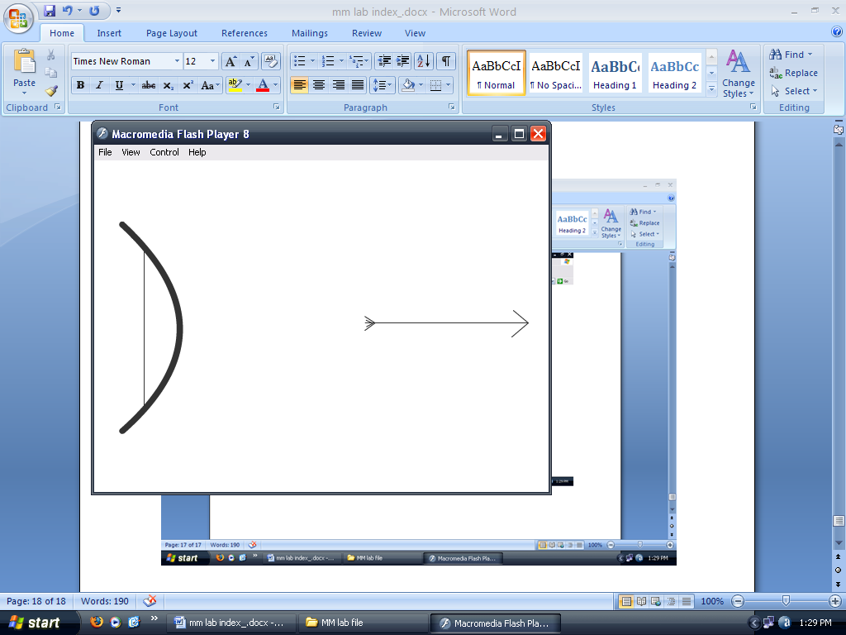

**Animation No. :-**

**Aim :- Design a tetris game in Flash.**

1. Open a new Flash Document.
2. A box is made in a layer in which the tetris pieces will fall.
3. Three objects are drawn, all in different layers.
4. One by one every piece is allowed to fall with the help of motion tween.

**Created By :- Rohit Aggarwal**

**Roll No :- 7CS-097**

**OUTPUT :**

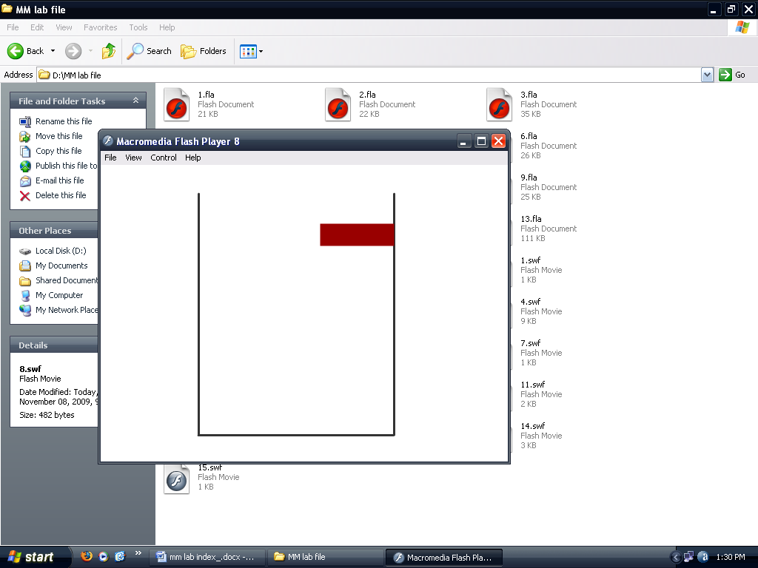

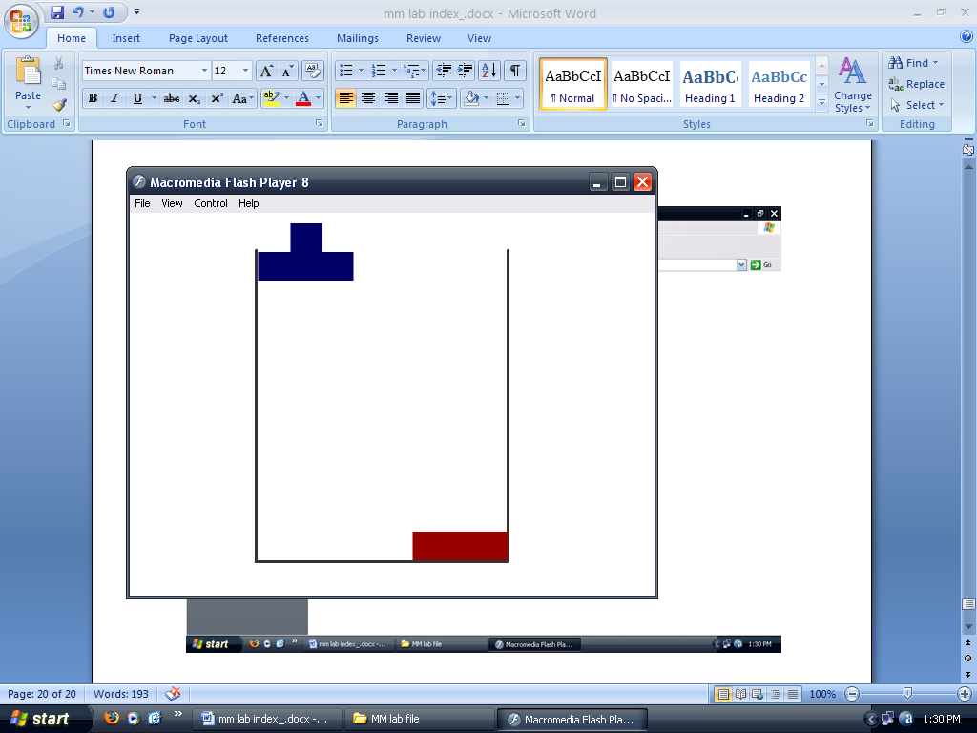

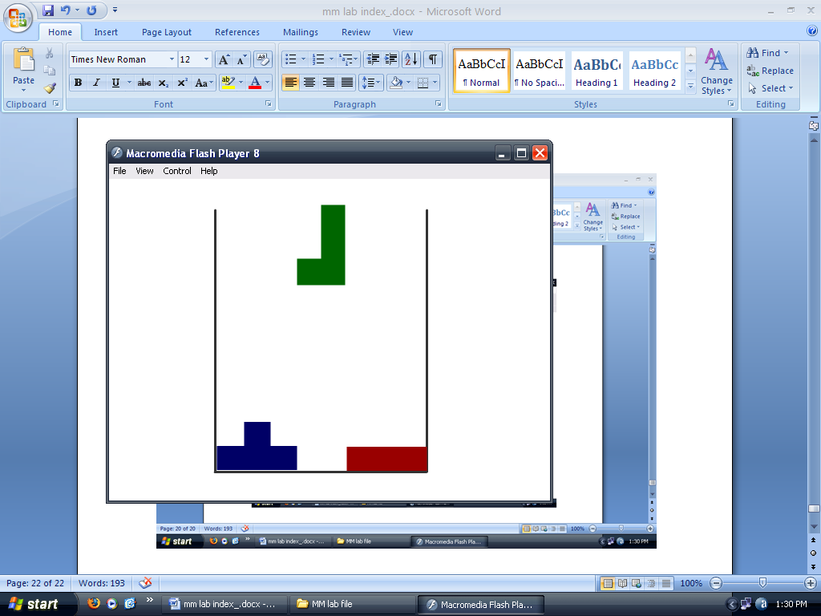

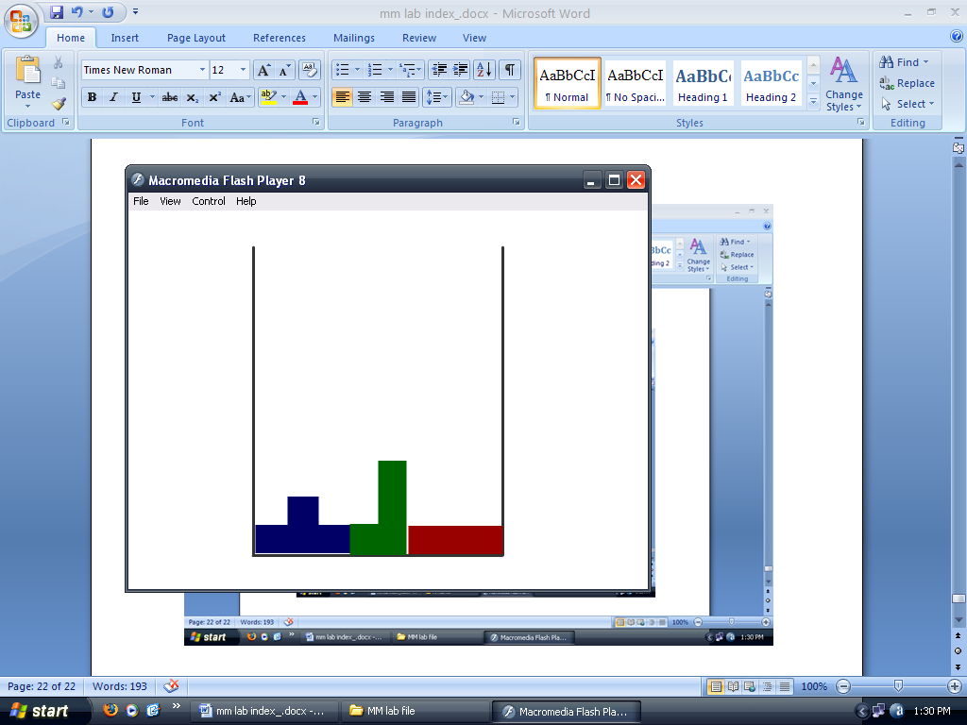

**Animation No. :-**

**Aim :- Create a traffic lights system in Flash.**

1. Open a new Flash Document.
2. 3 buttons are drawn namely:
   1. Red
   2. Yellow
   3. Green
3. A symbol like a car is drawn.
4. ActionScript is used to stop animation when pressed Red.
5. ActionScript is used to play animation when pressed green.

**Created By :- Rohit Aggarwal**

**Roll No :- 7CS-097**

**OUTPUT :**

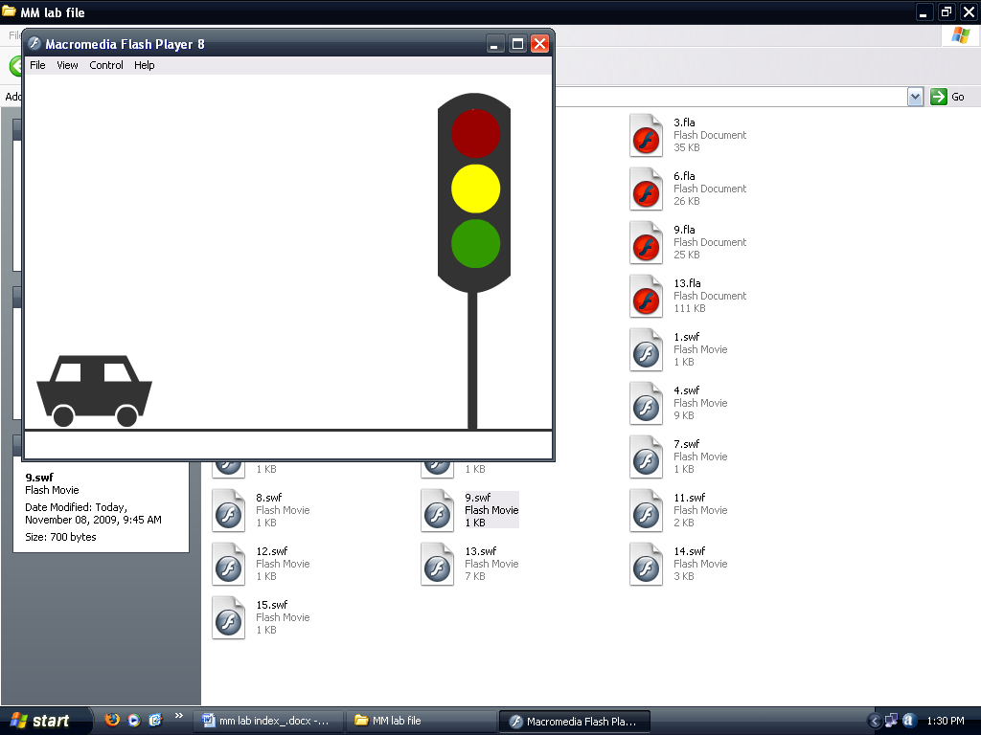

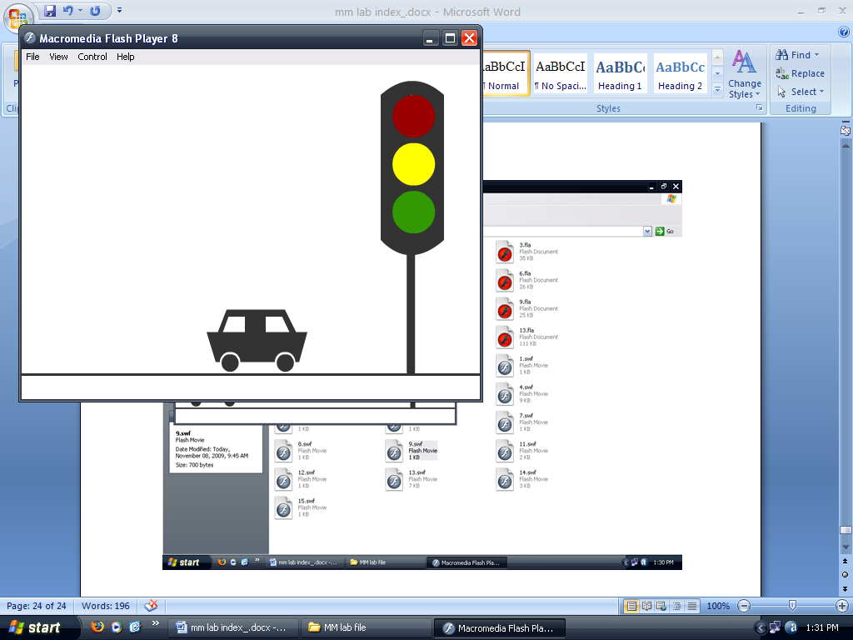

**Animation No. :-**

**Aim :- Create a spot light in Flash.**

1. Open a new Flash Document.
2. Same text but with different colors is placed into 2 different layers. For example the text may be “SPOTLIGHT”.
3. A mask layer is added. One layer with the darker text is placed beneath the mask layer.
4. In the mask layer, a circle is drawn.
5. The circle is motion tweened to move to the right of the frame.

**Created By :- Rohit Aggarwal**

**Roll No :- 7CS-097**

**OUTPUT :**

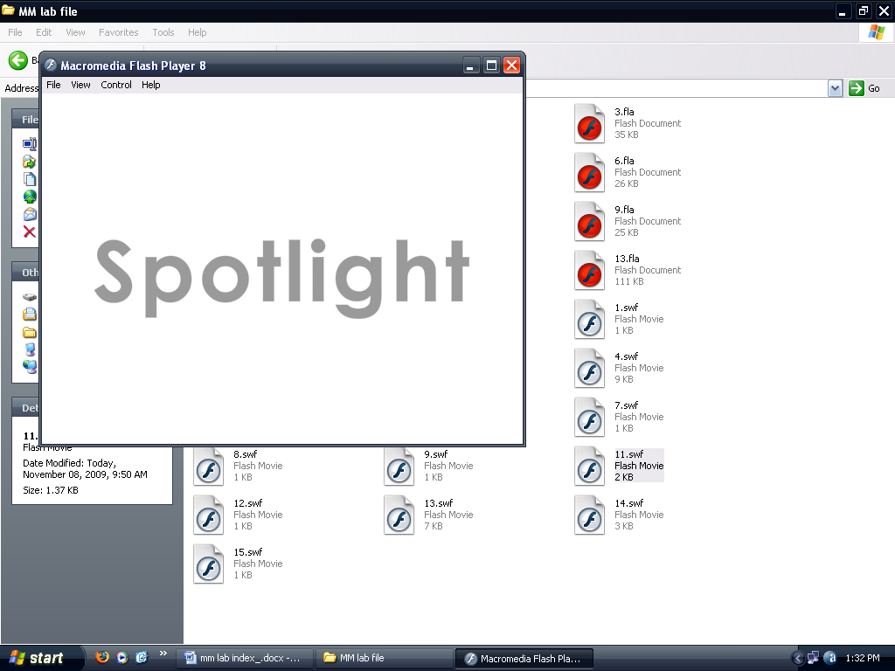

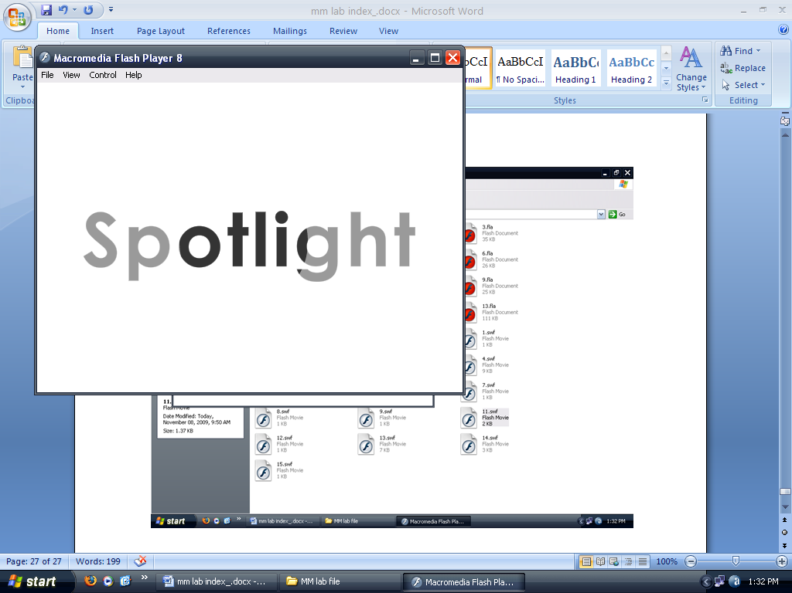

**Animation No. :-**

**Aim :- Design and simulate a snooker pool table.**

1. Open a new Flash Document.
2. The pool table is drawn in Layer 1.
3. The cue stick is a symbol which moves back and forth because of motion tween.
4. The cue ball is made.
5. Other balls with color red blue and green are made in different layers.
6. The cue ball is made to hit by cue stick.
7. Balls disperse.

**Created By :- Rohit Aggarwal**

**Roll No :- 7CS-097**

**OUTPUT :**

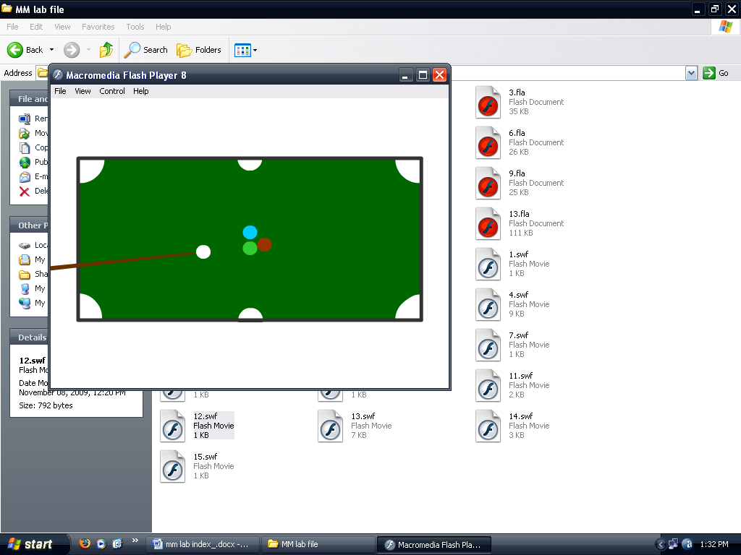

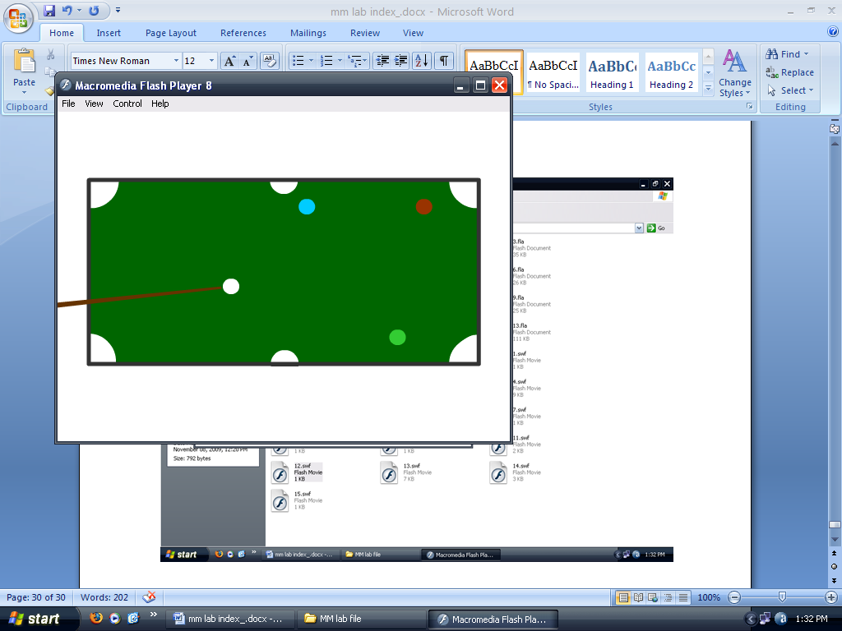

**Animation No. :-**

**Aim :- Design and simulate the writing of Alif-Laila.**

1. Open a new Flash Document.
2. “A” is taken out of the frame.
3. In the next keyframe “A” is taken back into the frame.
4. Then one by one letters “L”, ”I”, ”F”, ” L”, ”A”, ”I”, ”L”,”A” are introduced in consecutive keyframes.
5. These all frames are set to Shape Tween.

**Created By :- Rohit Aggarwal**

**Roll No :- 7CS-097**

**OUTPUT :**

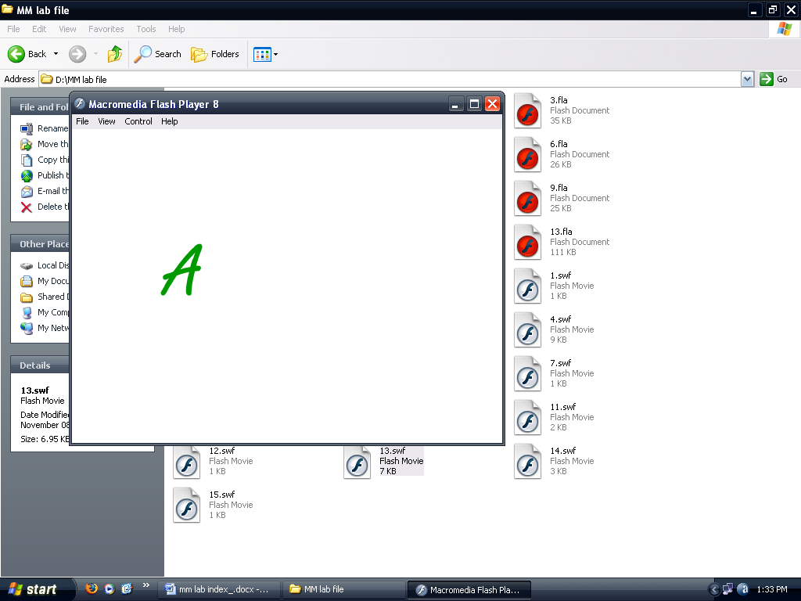

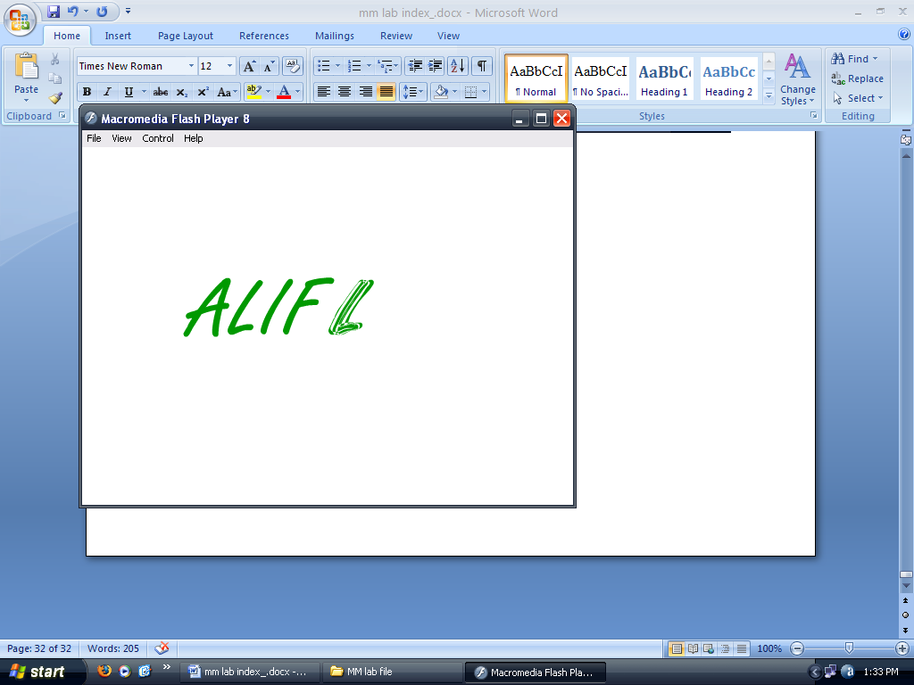

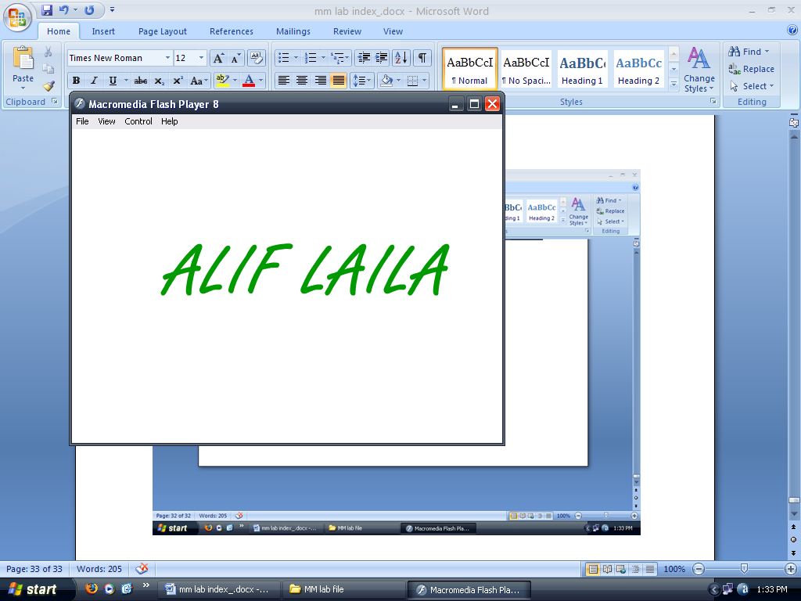

**Animation No. :-**

**Aim :- Create an animated button.**

1. Open a new Flash Document.
2. A button is made.
3. A symbol is made in which the button is animated to become a circle with shape tween.
4. The symbol is placed at the Timeline in Scene 1.

**Created By :- Rohit Aggarwal**

**Roll No :- 7CS-097**

**OUTPUT :**

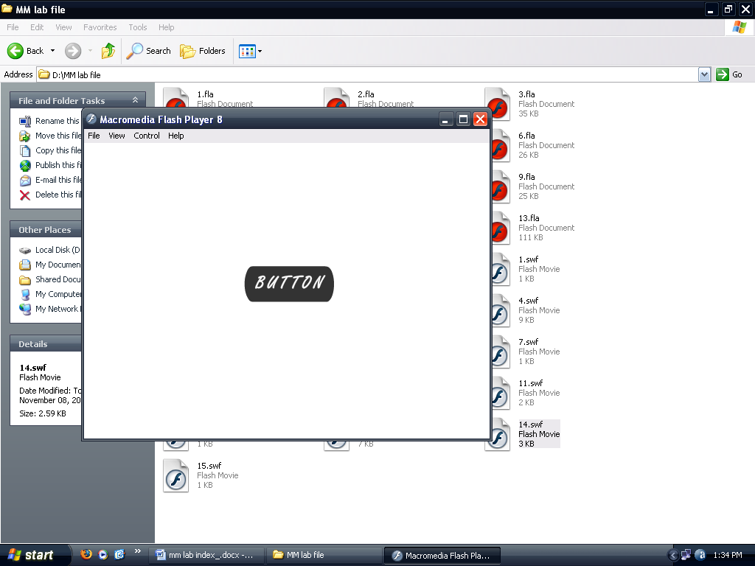

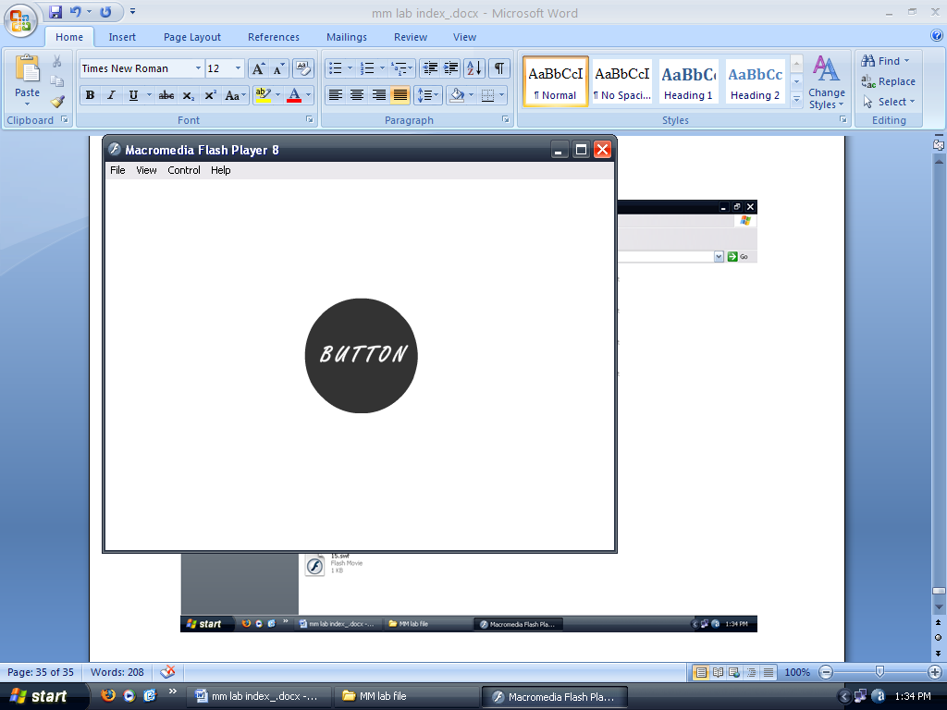

**Animation No. :-**

**Aim :- Implement splitting of a ball.**

1. Open a new Flash Document.
2. A ball is drawn in 1st keyframe.
3. It is brought downward in the next keyframe.
4. It is split into 2 pieces.
5. The two pieces are then moved to different directions.
6. All frames are set to shape tween.

**Created By :- Rohit Aggarwal**

**Roll No :- 7CS-097**

**OUTPUT :**

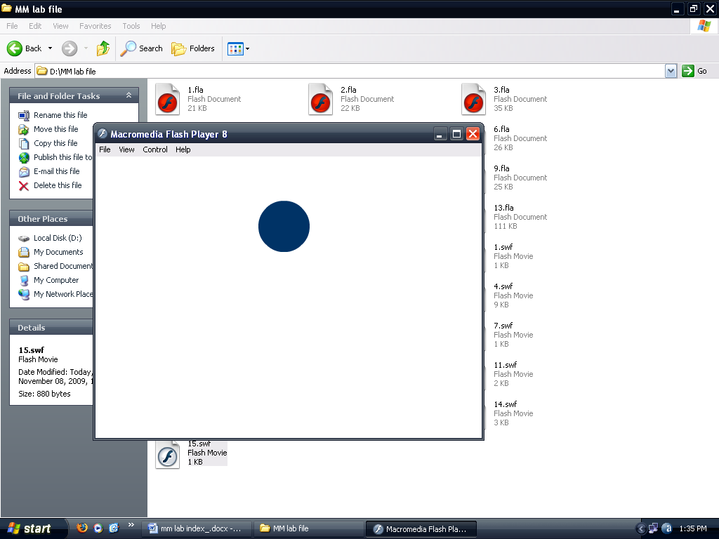

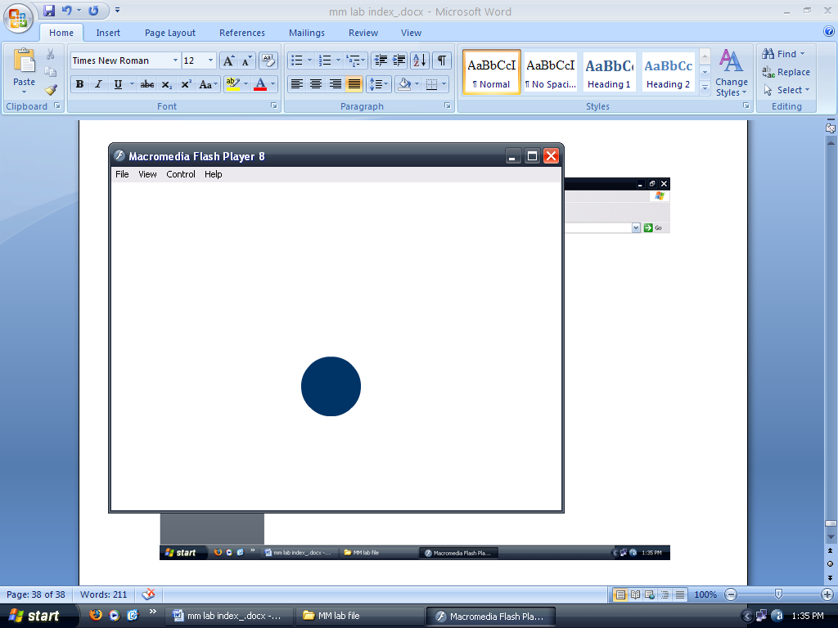

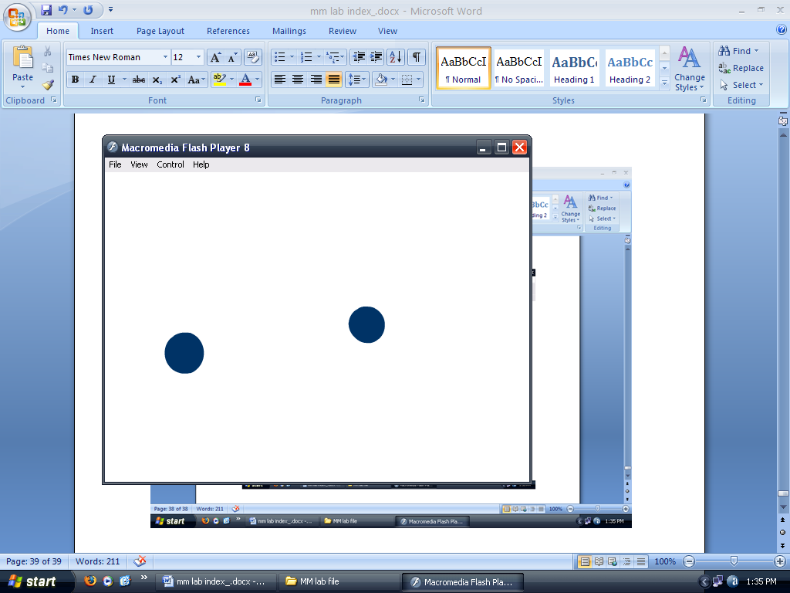

**Animation No. :-**

**Aim :- Design a birthday greeting card in Flash.**

1. Open a new Flash Document.
2. A cake is make with pencil tool.
3. Happy B’y is written in the next key frame.
4. Frames are shape tweened.

**Created By :- Rohit Aggarwal**

**Roll No :- 7CS-097**

**OUTPUT :**

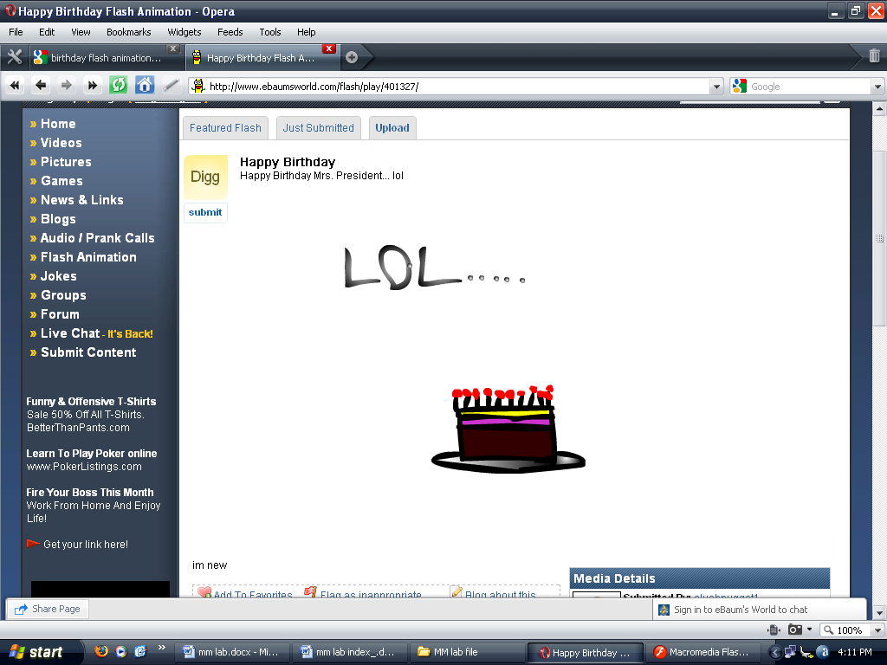

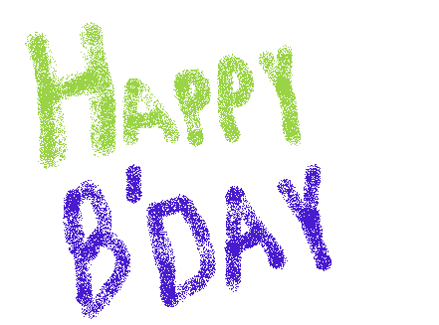

**Animation No. :-**

**Aim :- Design and simulate our solar system in Flash.**

1. Open a new Flash Document.
2. Sun is made in the centre in Layer 1.
3. 9 different motion guide layers are added for each planet.
4. Motion guides are then made for each planet.
5. Every planet with its name is made in a new layer under its own motion guide.
6. The motion is tweened so that the planets revolve around the sun anti-clockwise other than Venus and Neptune.
7. Venus and Neptune are made to rotate clockwise.

**Created By :- Rohit Aggarwal**

**Roll No :- 7CS-097**

**OUTPUT :**

